**Arizona Pie and Bar Charts**



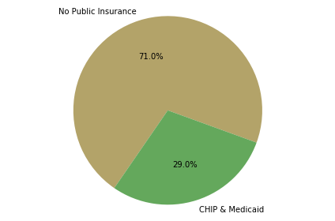



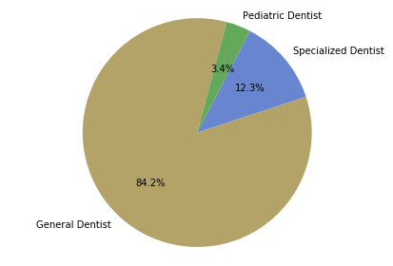





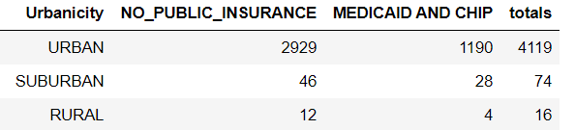 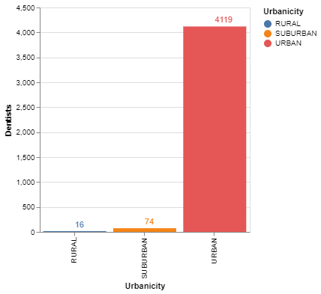

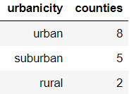

|  |  |
| --- | --- |
| C:\Users\Panda Bear\AppData\Local\Microsoft\Windows\INetCache\Content.MSO\21CEEF0F.tmp | Note: Arizona has only 15 counties and each of them is geographically very large. For example, Maricopa County is 9,222 square miles and Coconino County is almost twice as big as Maricopa.  Therefore, the higher number of urban counties is a deceptive feature. |

